Experiment: Effect of Robot Speed on Cycle Time and Productivity

1. Aim
To investigate the effect of robot operating speed on cycle time and productivity in an industrial robotic system.

2. Objective
1. To study the effect of robot speed on cycle time and productivity.

3. Theory
Robot speed is the rate at which a robot moves its joints or end effector during an operation. It directly influences the time required to complete a task and the number of products a robot can process per unit time.
Cycle time is the total time required by a robot to complete one complete operation, such as picking a component, moving it to another location, placing it, and returning to its initial position.
Cycle time can be expressed as:
Tc=Tm+Th+Tp+Td
Where:
- Tc = Total cycle time (seconds)
- Tm = Robot movement time
- Th = Workpiece handling time
- Tp = Processing time
- Td = Delay or waiting time
For a simplified movement where the distance and motion profile are fixed:
Tm= D/V
Where D is the travel distance and Vis the average robot speed. This approximation assumes constant average speed; actual robot motion includes acceleration and deceleration.

Productivity
Productivity indicates the number of products completed per unit time.
P=3600/Tc
Where:
- P = Theoretical productivity (cycles per hour)
- Tc = Cycle time in seconds
- For a productive shift of H hours and an operating availability factor A
P=3600HA/T_{C}
Here, A is expressed as a fraction between 0 and 1. This estimate assumes one product per cycle and excludes any additional variation in cycle time.

4. Experimental Procedure
- Set up a robot for a pick-and-place operation using a fixed path and workpiece.
- Set the robot speed to 20% of its configured speed limit.
- Execute the operation and measure the total cycle time.
- Repeat the operation at speeds of 40%, 60%, 80%, and 100%.
- Perform multiple trials at each speed and calculate the average cycle time.
- Calculate theoretical productivity using the measured cycle time.
- Observe any changes in vibration, accuracy, stability, and handling reliability.
- Tabulate and compare the results.

5. Observation Table
The following values are illustrative examples, not actual experimental measurements. Replace them with measured values from your robot or simulation.
Robot speed (%) | Cycle time (s) | Theoretical productivity (cycles/hour)
20 | 12.0 | 300
40 | 8.0 | 450
60 | 6.0 | 600
80 | 5.0 | 720
100 | 4.5 | 800

Sample Calculation
For a robot operating at 60% speed, assume the measured cycle time is 6 seconds.
Theoretical productivity is:
P=3600/Tc
P= 3600/6=600
Therefore, the theoretical productivity is 600 cycles per hour.
For an 8-hour shift operating at 85% availability:
P_{actual}=(3600*8*0.85)/6
P_{actual}=4080 cycles per shift
This estimate assumes one completed product per cycle and no additional losses beyond the availability factor.

6. Result Analysis
Effect of Robot Speed on Cycle Time
Illustrative data showing cycle time decreasing as robot speed increases.

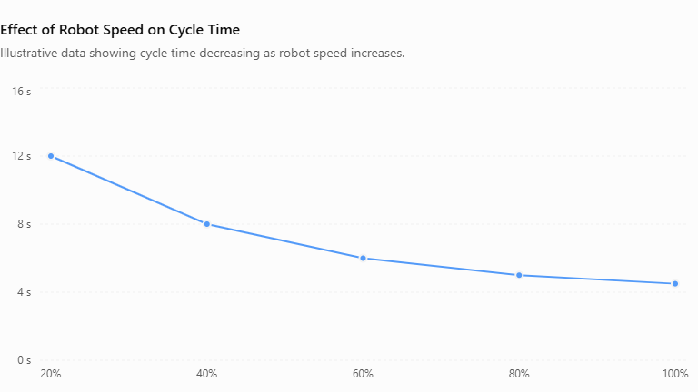

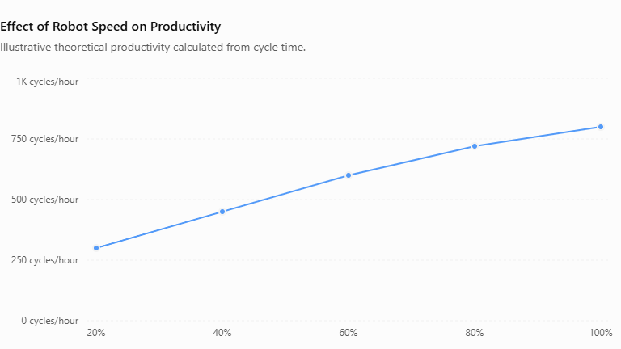

Conclusion
The effect of robot speed on cycle time and productivity was studied. Increasing robot speed generally reduces cycle time and increases theoretical productivity. However, the optimum operating speed must also consider positioning accuracy, motion stability, payload, safety, and equipment life.

Matlab Prog:
clc;
clear;
close all;

% Experiment: Effect of Robot Speed on Cycle Time
% and Productivity

% Robot speed in percentage
speed = [20 40 60 80 100];

% Fixed robot travel distance (m)
D = 2;

% Maximum average robot speed (m/s)
Vmax = 0.5;

% Fixed time for gripping, releasing and other operations (s)
Th = 2;

% Calculate cycle time
% Movement time = Distance / Actual average speed
V = (speed/100) * Vmax;
Tm = D ./ V;

% Total cycle time
Tc = Tm + Th;

% Calculate theoretical productivity (cycles per hour)
P = 3600 ./ Tc;

% Display results
Results = table(speed', V', Tm', Tc', P', ...
'VariableNames', {'Speed_Percent', ...
'Speed_mps', 'Movement_Time_s', ...
'Cycle_Time_s', 'Productivity_per_hour'});

disp('Robot Speed, Cycle Time and Productivity');
disp(Results);

% Plot 1: Speed vs Cycle Time
figure;
plot(speed, Tc, '-o', 'LineWidth', 2, ...
'MarkerSize', 8);
grid on;
xlabel('Robot Speed (%)');
ylabel('Cycle Time (seconds)');
title('Effect of Robot Speed on Cycle Time');

% Plot 2: Speed vs Productivity
figure;
plot(speed, P, '-s', 'LineWidth', 2, ...
'MarkerSize', 8);
grid on;
xlabel('Robot Speed (%)');
ylabel('Productivity (cycles/hour)');
title('Effect of Robot Speed on Productivity');

% Combined comparison
figure;

yyaxis left;
plot(speed, Tc, '-o', 'LineWidth', 2);
ylabel('Cycle Time (seconds)');

yyaxis right;
plot(speed, P, '-s', 'LineWidth', 2);
ylabel('Productivity (cycles/hour)');

xlabel('Robot Speed (%)');
title('Robot Speed vs Cycle Time and Productivity');
grid on;
legend('Cycle Time', 'Productivity', ...
'Location', 'best');

Output
Speed_Percent | Speed_mps | Movement_Time_ | Cycle_Time_ | Productivity_per_hour
20 | 0.1 | 20 | 22 | 163.664
40 | 0.2 | 10 | 12 | 300
60 | 0.3 | 6.66 | 8.66 | 415.38
80 | 0.4 | 5 | 7 | 514.29
100 | 0.5 | 4 | 6 | 600

